Home Work 5

1.

#include <stdio.h>

int max(int x , int y){

return x>y ? x : y;

}

int main( void )

{

int x , y , z;

scanf("%d%d%d",&x,&y,&z);

printf("maximum integer : %d" , max(x,max(y,z)));

return 0;

}

Output

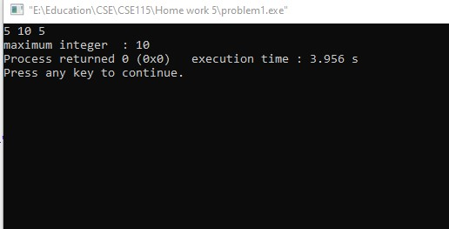

2.

#include <stdio.h>

int factorial(int x) {

if(x==0)

return 1;

return x*factorial(x-1);

}

int main( void )

{

int x, n;

scanf("%d%d", &x,&n);

double total =1;

for(int i=1;i<=n;i++) {

double res = (double)x/(double)factorial(i);

if(i&1)

res=-res;

total+=res;

x*=x;

}

printf("answer is : %f", total);

return 0;

}

Output

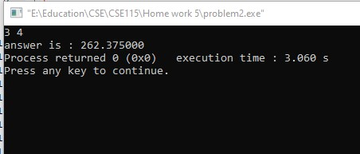

3.

#include <stdio.h>

const char* prime(int n){

for(int i=2;i<=n/2;i++)

if(n%i==0)

return "Not Prime";

return "Prime";

}

int main( void )

{

int n;

scanf("%d",&n);

n<=0 ? printf("Wrong input") : printf("%s",prime(n)) ;

return 0;

}

Output:

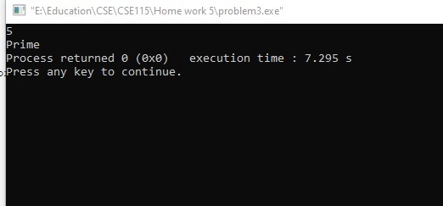

4.

#include <stdio.h>

int power_of_x(int a , int x){

if(x==0)

return 1;

return a*(power_of_x(a , x-1));

}

int main( void )

{

int a,x;

scanf("%d %d", &a,&x);

printf("answer is : %d" , power_of_x(a,x));

return 0;

}

Output:

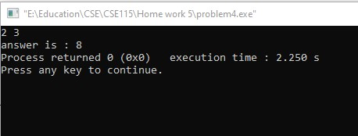

5.

a. The variables which are having scope/life throughout the program are called global variables. Global variable is defined outside the main function. So, this variable is visible to main function and all other sub functions.

b. Variables that are declared inside a function or block are called local variables. They can be used only by statements that are inside that function or block of code. Local variables are not known to functions outside their own. The following example shows how local variables are used. Here all the variables a, b, and c are local to the main() function.

6.

a)

int sum(int n)  
{  
int i,s=0;  
for(i=0;i<=n;i++)  
s=s+i;  
return s;  
}  
  
b)

void listNumbersAsc(int start, int end)

{  
if(start <= end)  
{  
printf("%d ", start);  
listNumbersAsc(start+1, end);  
}

}

c)

void listNumbersDesc(int start, int end)

{  
if(start <= end)  
{  
printf("%d ", end);  
listNumbersDesc(start, end-1);  
}

}

d)

double harmonicSum(int n)  
{  
double i, sum = 0.0;  
for (i = 1; i <= n; i++)  
sum = sum + 1/i;  
return sum;  
}

e)

int sumOfDigits(int x)  
{  
int m,sum=0;  
while(x>0)  
{  
m=x%10;  
sum=sum+m;  
x=x/10;  
}  
return sum;  
}